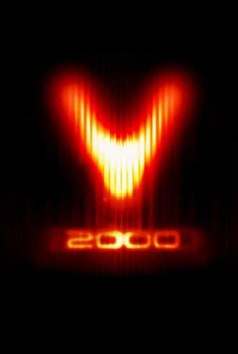

Keyboard Controls Mouse Controls

Left and Right cursor Mouse Left or Right Rotate craft left or right
Keys, < and > Rotate craft left or right

Up and Down cursor Pitch nose up or down/raise or Mouse back and forward Pitch nose up or down/raise or
Keys, S and X lower guns in Hovercraft mode lower guns in Hovercraft mode

Space Thrust Left Mouse Button Thrust

Right Shift Reverse Thrust Right Mouse Button Fire current weapon

Tab Switch between full flight and
Hovercraft mode-fuel permitting Joystick Controls

Return, ?, or A Fire current weapon Joystick Left or Right Rotate craft left or right

CTRL Holding while firing will launch a Joystick Back or Forward Pitch nose up or down/raise or
Megablast, if any are equipped lower guns in Hovercraft mode

Pg Up and Pg Dn Select weapon Fire Button 1 Thrust

M Switch to Map View Fire Button 2 Fire current weapon

Escape or P Pause game an access option

C Beam up person or cargo

D Beam down person or cargo

E Select cargo (if expanded cargo
Pod is fitted)

